Student’s name | …………………………………………………….…… | Grade | 2
Subject | Computer | Week No. | 15
Lesson Title | Pictograph | Unit
Worksheet No. ( 15 ) (Answer)

Question A: Write the correct name of each part.
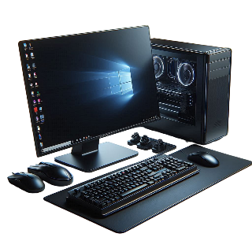
Computer | Menu | MS Word

Menu
MS Word
Computer
Good Luck

